EnergieBee Core and the Planning Design: Comparison and IoT Framing
19 October 2026

Part 1 — Two halves of one system
EnergieBee core and the Predbat.js + SQL design (called “the planning design” below; see the companion report Predbat in Node.js + SQL) are not competitors: EnergieBee is a ledger of the past and the planning design is a controller of the future. EnergieBee answers “what happened in this half-hour, what did it cost, and how do we know?”; the planner answers “what should the battery do next?”. The new system needs both, sharing one time model and one fact store.
 | EnergieBee core (Technext report, 16 Oct 2026) | Predbat-style planning design
Core question | What happened, priced and proven | What to do next, cheapest
Direction of data | Read-only: providers → facts → serving | Read and write: facts → plan → inverter commands
Unit of truth | Versioned fact with its raw payload | Disposable plan, recomputed every cycle
Main output | site_hh / site_day: flows, costs, carbon, checks | plan_slot: action, target SoC, predicted cost
Stage | Working prototype, 1 home, SQLite, measured | Design, multi-tenant, PostgreSQL, not yet measured
The useful finding: EnergieBee already solved most of what the planning design hand-waves (provenance, versioning, tariffs, data quality), while the planning design adds the one thing EnergieBee lacks entirely — a control path back to the device.

Side by side
Both use the same 30-minute slot grid over 5-minute samples; they diverge on how facts are stored and on whether anything flows back to the device.
Dimension | EnergieBee core | Planning design | Verdict for the new system
Time grid | slot_start epoch int, % 1800 = 0; 5-min readings; local_date per site | slot_start timestamptz on 30-min grid; 5-min simulation steps | Same model. Keep EnergieBee’s CHECK on alignment
Measurement model | Generic source × metric × series registry; narrow fact rows (reading, interval_fact) | Wide typed telemetry row per inverter (soc, battery_w, grid_w, pv_w, load_w) | EnergieBee’s registry: new metrics need no migration
Versioning | Append-only, bitemporal: recorded_at / superseded_at in ms; “as known at T” queries | Upserts on primary key; corrections overwrite silently | EnergieBee’s. Plans must be reproducible from the facts they used
Provenance | Every fact carries raw_id; body kept as a file, SHA-256 dedup; quarantine on bad shape | None | EnergieBee’s. Essential for debugging a bad charge decision
Forecasts | forecast_fact: every issue kept, own forecast stored hourly and scored | pv_forecast: one current row per slot | EnergieBee’s, with its change-only fix (539 → 84 rows per sync)
Tariffs | Shared tariff + versioned rate_interval; per-meter tariff_agreement; VAT, standing charges, registers, learned IOG window | tariff_rate copied per site per slot | EnergieBee’s. Prices are shared by every home on a tariff
Derived data | site_hh / site_day disposable, rebuilt from facts; METHOD_VERSION | plan_run + plan_slot append-only, kept | Both derived. Plans follow EnergieBee’s rule: keep only what was executed
Data quality | final / provisional / missing states, quality bit flags, up to 12 check codes per day | stale_inputs status only | EnergieBee’s states feed the planner’s freshness gate
Device attributes | site_attribute ranked by source (installer, measured, provider, estimated); battery efficiency measured per day (94.0%) | Static battery config (soc_max, loss) | EnergieBee’s: the planner should use measured capacity and efficiency
Control path | None — read-only | inverter_command with desired state, diff, read-back | Planning design’s — EnergieBee has nothing here
Optimisation | None (forecast only, computed on request) | Simulator + greedy optimiser, PV10 weighting | Planning design’s
Tenancy | One home; facts have no site_id; serial scheduler ≈ 25 homes per 10-min cycle | tenant_id, SKIP LOCKED scheduler, worker pool | Planning design’s, plus add site_id to facts
Cadence | Sync every 10 min (≈ 23.5 s each) | Plan every 5 min | 5-min telemetry and plan; 10–30 min for slow sources (meters, rates)
Storage | SQLite via node:sqlite, files in data/raw | PostgreSQL | PostgreSQL + object storage for raw; SQLite on the edge agent
Evidence | Measured: 4.3 MB DB + 31.8 MB raw per home per day before fixes | Unmeasured | Adopt EnergieBee’s habit: every growth figure measured and queryable
Source: Technext, EnergieBee core — Database architecture, report edition 19 Oct 2026, sections 1–7.

Best of both: decisions
Take EnergieBee’s data layer whole and put the planner and executor on top of it. The planning design’s own input tables (tariff_rate, pv_forecast, load_history, telemetry) are replaced, not merged.
Adopt from EnergieBee
- The fact layer as-is: source, metric, series, reading, interval_fact, forecast_fact, raw_payload — append-only, bitemporal, with provenance.
- The tariff model: shared tariff and rate_interval, per-meter tariff_agreement, vat_rate. The planner’s 96 import and export prices become a query over these, not a copied table.
- Data states and quality bits. The planner’s freshness gate reads them: a slot with missing load history or an unpriced half-hour is a reason to plan conservatively.
- Ranked site_attribute. The simulator uses the measured battery capacity and the measured daily efficiency (e.g. 94.0%) instead of a typed-in 0.96.
- The disposable-serving principle with METHOD_VERSION — a method change is a rebuild, not a migration.
Keep from the planning design
- The control loop: simulator, optimiser, plan_run, desired-state executor, inverter_command with read-back.
- Multi-tenancy and parallel scheduling (tenant_id, SKIP LOCKED, worker pool).
- Deployment modes (edge, cloud, hybrid).
One new link, from planner to ledger. Store each plan’s predicted half-hours as a forecast_fact issue of a core_plan source — exactly as EnergieBee stores core_forecast. Then the existing accuracy scoring compares what the plan predicted against site_hh, and planner quality becomes a measured number.
Traps both designs fall into — avoid them once
Trap | In EnergieBee (measured) | In the planning design (projected) | Rule
Storing the whole output every cycle, changed or not | 539.4 forecast rows per sync, 59% of DB bytes; fixed to 84 | 288 runs × 96 slots = 27,648 plan_slot rows per site per day | Write a new issue only when a value changes; keep executed slots for ever, others for 7 days
Dedup key includes the clock | Request URLs carried the time, so 22 raw files per sync; fixed to 7 | Same risk for any polled inverter API | Hash source + body, never the request URL
Work that grows with history | Full rebuild every sync: 175 ms at 15 days, ≥ 4.4 s at a year; fixed with daily battery_stock checkpoint | Load prediction scanning all history | Checkpoint daily state; read bounded windows only
Serial per-home loop | ≈ 25 homes per 10-min cycle | — | Parallel workers per site from day one
Shared data fetched per home | Rate pages and carbon fetched and stored per home | Same if tariffs are per site | Fetch once per tariff or region per cycle
Logs never pruned | sync_run, rebuild_queue grow for ever (queue fixed) | event_log, inverter_command | Retention policy per table at creation time

Merged schema
EnergieBee’s tables stay as they are (ported to PostgreSQL); the planning tables attach to them. Six changes make the join.
Change | Why
Add site_id to reading, interval_fact, forecast_fact (NULL for region series) | Partition and scope by home — EnergieBee lists this as still open
Inverter and battery become device rows; their limits become site_attribute / device.attrs | One device registry for meters, inverters, batteries, EV chargers
Drop tariff_rate, pv_forecast, load_history, telemetry | Replaced by facts and the tariff model
plan_run records facts_as_of and method_version | A plan can be rebuilt exactly with withKnownAt(facts_as_of)
Store plans only on change; publish predictions as core_plan forecast issues | Avoid the 27,648 rows/day trap; score plans against site_hh
inverter_command links to the read-back raw_payload | Provenance for actions, not only for facts
-- PostgreSQL port of EnergieBee facts, scoped and partitioned
ALTER TABLE reading ADD COLUMN site_id bigint REFERENCES site(id);
ALTER TABLE interval_fact ADD COLUMN site_id bigint REFERENCES site(id);
ALTER TABLE forecast_fact ADD COLUMN site_id bigint REFERENCES site(id);
-- reading: PARTITION BY RANGE (ts), monthly; index (site_id, series_id, ts)
-- Overlap checks become real constraints
ALTER TABLE rate_interval ADD CONSTRAINT rate_no_overlap
EXCLUDE USING gist (tariff_id WITH =, component WITH =, register WITH =,
tstzrange(valid_from, valid_to) WITH &&)
WHERE (superseded_at IS NULL);
-- Planning tables, attached to the fact layer
CREATE TABLE plan_run (
id bigserial PRIMARY KEY,
site_id bigint NOT NULL REFERENCES site(id),
created_at timestamptz NOT NULL DEFAULT now(),
facts_as_of timestamptz NOT NULL, -- bitemporal cut used for inputs
method_version text NOT NULL,
plan_hash text NOT NULL, -- skip insert when unchanged
soc_start_kwh numeric(6,2) NOT NULL,
metric_best numeric(10,2),
status text NOT NULL -- 'ok' | 'stale_inputs' | 'error'
);
-- plan_slot as in the planning design; predictions also written to
-- forecast_fact under source 'core_plan' for accuracy scoring
CREATE TABLE inverter_command (
id bigserial PRIMARY KEY,
device_id bigint NOT NULL REFERENCES device(id),
plan_run_id bigint REFERENCES plan_run(id),
desired jsonb NOT NULL,
status text NOT NULL DEFAULT 'pending', -- pending|sent|acked|failed
readback_raw_id bigint REFERENCES raw_payload(id),
created_at timestamptz NOT NULL DEFAULT now(),
acked_at timestamptz
);

Part 2 — Ultimately, an IoT and telemetry system
Strip away the energy vocabulary and the merged system is a standard IoT platform: a fleet of devices emits time-series telemetry, a platform stores and derives from it, and a control loop sends desired state back down. EnergieBee is the upward path (telemetry → facts → analytics); the planner and executor are the downward path (analytics → decisions → commands).
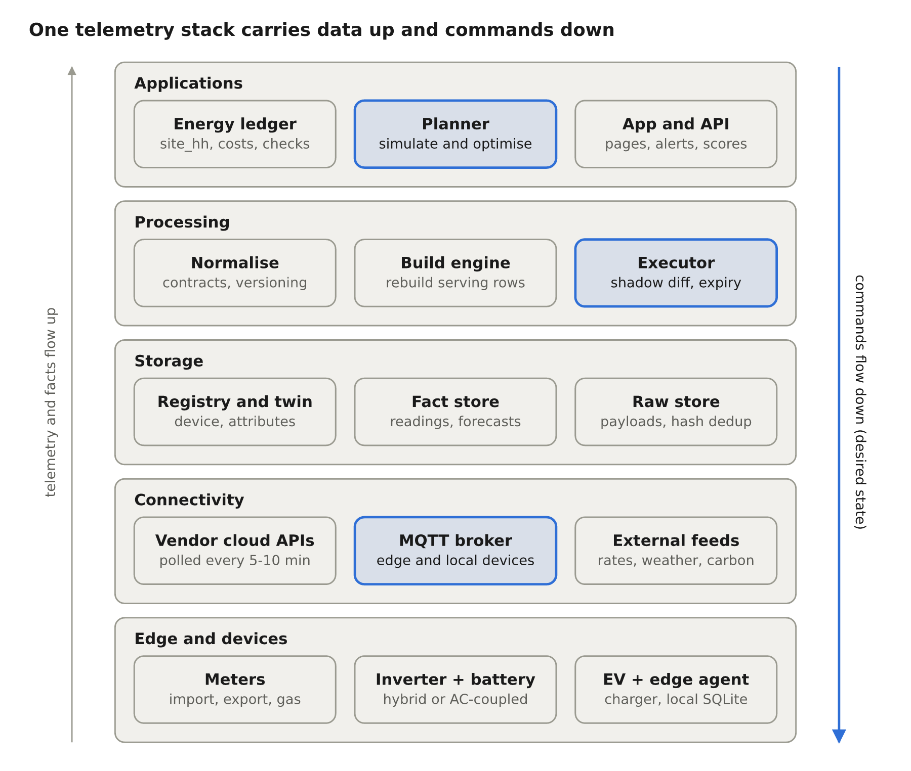
The merged system as an IoT stack · 5 layers
Framing it this way settles design questions by convention rather than invention: device identity, shadows, at-least-once delivery, store-and-forward, retention tiers and per-tenant topic security are solved patterns. What stays energy-specific is narrow — the slot grid, tariff pricing, and the optimiser — and those sit in the top layer only.
Generic IoT layer | In this system
Devices and edge | Meters, inverter, battery, EV charger, edge agent
Connectivity | Vendor cloud APIs (polled), MQTT, external data feeds
Storage | Device registry and twin, bitemporal fact store, raw object store
Processing | Adapters with source contracts, build engine, executor
Applications | Energy ledger, planner, app and alerts

Device model: twin, shadow and topics
Every physical thing is a device with an identity, a twin (what we believe it is) and a shadow (what it reports versus what we want). The existing tables already map onto this; only the names are new.
IoT concept | Meaning | Where it lives
Device identity | One row per physical or virtual device, with a stable external id | device (meter MPAN, inverter serial, EV id)
Digital twin | Slow-changing properties with their source and history | site_attribute, device.attrs, device_attr_version
Telemetry | Time-stamped measurements the device emits | reading (instant), interval_fact (energy over a period)
Reported state | The configuration the device says it is running | Read-back of schedule → raw_payload + reading
Desired state | The configuration we want it to run | inverter_command.desired
Shadow delta | Desired minus reported; non-empty means act | Executor diff
Device health | Last seen, last error, connectivity | connection, edge_agent.last_seen_at
Device kinds: meter_import, meter_export, meter_gas, inverter, battery, ev_charger, edge_agent. A battery is its own device even when the inverter reports for it, so a second battery or a replacement keeps its own history.
MQTT topics (hybrid and edge modes). The edge agent and local devices speak MQTT; the cloud bridges vendor APIs into the same shape, so the rest of the system sees one interface.
eb/{tenant}/{site}/{device}/telemetry # 5-min batch: [{metric, ts, value, quality}]
eb/{tenant}/{site}/{device}/state/reported # schedule and mode the device is running
eb/{tenant}/{site}/{device}/state/desired # retained; written by the executor
eb/{tenant}/{site}/{device}/cmd/ack # {command_id, status, error}
eb/{tenant}/{site}/edge/health # agent heartbeat, version, plan_run held
- Telemetry is QoS 1 (at-least-once); the store deduplicates on (series_id, ts) plus value, which the append-only fact rules already do.
- Desired state is a retained message, so a device or agent that reconnects gets the current target immediately.
- Each device authenticates with its own certificate or token, scoped to its own topic prefix; tenants never share a namespace.

Telemetry pipeline rules
At fleet scale the system is an ingestion problem first: telemetry rows are steady and small, forecasts are bursty and large, and commands are rare but must never be wrong.
Fleet-scale load (projections from EnergieBee’s measured per-home figures, after its fixes):
Stream | Per home per day | 100,000 homes per day | Average rate
5-min device readings (7 metrics) | 1,949 rows | 195 million rows | ≈ 2,260 rows/s
Forecast rows (change-only, 144 syncs) | 12,096 rows | 1.21 billion rows | ≈ 14,000 rows/s
Raw payloads (change-only) | 1,008 files | 101 million files | ≈ 1,170 files/s
Inverter commands (write on change) | tens | a few million | low, but latency-sensitive
Forecasts, not device telemetry, still dominate. Most of that is avoidable: region series (carbon) and tariff prices must be fetched and stored once per region or tariff, not per home, and per-home forecasts (solar) should be fetched at the provider’s own update rate rather than every sync.
Rules
- At-least-once in, exactly-once stored. Any message may arrive twice; the fact rules (same value → no write) make replays harmless. Dedup raw bodies by hash of source + body.
- Late and revised data is normal. Meter data arrives about a day late and is revised for days; Sunsynk daily totals grow until the day closes. Bitemporal facts absorb this, the ledger marks half-hours provisional → final, and the planner reads with facts_as_of.
- Two clocks per sample. Keep device time (ts) and arrival time (recorded_at); align to the 5-min grid at ingest and flag clock skew as a quality bit.
- Store and forward at the edge. The agent buffers telemetry in SQLite while offline and replays on reconnect; rule 1 makes the replay safe.
- Commands expire. Every desired state carries valid_until (the end of its window). A command delivered late is dropped, never applied stale; the device falls back to Demand.
- Quarantine, don’t guess. A payload with an unexpected shape is stored with a reason and produces no facts (EnergieBee’s quarantine()), and the planner treats that input as missing.
- Retention by tier.
  - Hot (0–7 days, PostgreSQL): all readings, all plan runs, command log.
  - Warm (to 2 years, compressed partitions): readings, executed plan slots, forecast issues of record.
  - Cold (object storage, no expiry): raw payloads. Several providers keep no history (Sunsynk 5-min data is gone after 90 days), so this is the only copy.
- Partition by time, scope by site. Monthly range partitions on ts, every index leading with site_id; no read path crosses homes.
Source for per-home figures and provider retention: Technext, EnergieBee core — Database architecture, sections 6 and 8 and the post-fix update table.

